** MINISTRY OF EDUCATION AND TRAINING**

**FPT UNIVERSITY**

Capstone Project Document

The Roll System using Mobile Device

|  |  |
| --- | --- |
| **Group 1** | |
| **Group member** | Pham Huy Hoang – Team Leader – 60740  Nguyen Thanh Binh – Team Member - 60321  Nguyen Quoc Huy – Team Member - 60551  Do Minh Dat – Team Member - 60545 |
| **Supervisor** | Mr. Kieu Trong Khanh |
| **Ext. Supervisor** | N/A |
| **Capstone Project code** | RSM |

-Ho Chi Minh City, 09/2013-

*This page is intentionally left blank*

***ACKNOWLEDGEMENTS***

We wish to thank various people for their contribution to this project: Our teachers for their advices and participant in the final review, our friend for the valuable technical support.

Special thanks should be given to Mr.Kiều Trọng Khánh, our research supervisor for his professional guidance and the useful, constructive recommendations throughout the course of this project.

# Table of Contents

**Table of Contents 4**

**List of Tables 6**

**List of Figures 7**

A. Introduction 8

1. Project Information 8

2. Introduction 8

3. Current Roll Call System 8

4. Problem Definition 8

5. Proposed Solution 9

5.1 Feature functions 9

5.2 Advantage and disadvantage 9

6. Functional Requirement 10

6.1 Create Account 10

6.2 Instructor Management 10

6.3 Class Management 10

6.4 Student Management 10

6.5 Course Management 10

6.6 Roll Call Management 10

6.7 Attendance Checking 10

6.8 Stranger Alert 10

6.9 Attendance Report 11

7. Role and Responsibility 11

B. Software Project Management Plan 12

1. Problem Definition 12

1.1 Name of this Capstone Project 12

1.2 Problem Abstract 12

1.3 Project Overview 12

2. Project organization 14

2.1 Software Process Model 14

2.2 Roles and responsibilities 15

2.3 Tools and Techniques 16

3. Project Management Plan 17

3.1 Iteration 17

3.2 Iteration Detail 19

3.3 All Meeting Minutes 23

4. Coding Convention 23

# List of Tables

Table 1: Roles and Responsibility 11

Table 2: Hardware Requirement for Server 14

Table 3: Hardware Requirement for Mobile App 14

Table 4: Roles and Responsibility Details 16

Table 5: Iteration 18

Table 6: Phase 1: Preliminary Investigation or Analysis 19

Table 7: Phase 2: Face Detect & Recognize 20

Table 8: Phase 3: Student Management 20

Table 9: Phase 4: Roll Call Management 21

Table 10: Phase 5: Web Service Implement 22

Table 11: Phase 6: Attendance Checking 22

Table 12: Phase 7: Attendance Report 23

# List of Figures

Figure 1: Agile Development Model 15

# Introduction

## Project Information

* Project name: **The roll system using mobile device**
* Project Code: **RSM**
* Product Type: **Website, Phone Application**
* Start Date: **September 9th, 2013**
* End Date:

## Introduction

Roll system was known with HPLite32, SimplePass of HP fingerpint system; roll system with ID card using by almost corporation or company around the world; the system face identify by Uniqul – Finland publish on 7/15/2013 or LogonSmart by Asus. Today, the trend machines replace humans in the hard work or the work does not require high intelligence became popular. So roll system face recognition becomes ever more necessary. The number of students in a university as well as the number of employees in large corporations in Vietnam is increasing dramatically, which means that the system should have professional roll with accuracy high.

## Current Roll Call System

Below are some current roll call systems:

* By manual: This system is widely used in school, university. The instructor will call the name of each student, check the absent, then submit the result to log system.
* Using ID card: This system is usually used in corporations. Each employee has a card. The card will be read by a card reader to check the attendance of the employee.
* Using fingerprint: This system is currently used in FPT University. 15 minutes before and after a studying session, the student must show his fingerprint to a machine to take attendance.
* Using camera + face recognition: This system is just in experimental stage. Each classroom has a camera. At the beginning of the studying session, the instructor uses the computer, connect to the camera and take picture of classroom. The system will recognize the student in the picture, write to roll call log system.

## Problem Definition

Below are the advantage and disadvantage of current roll call systems:

* By manual

+ Advantage: Simple to implement, cheap.

+ Disadvantage: The roll call take 3-5 minutes, take effort of instructor, wrong roll call.

* Using ID card

+ Advantage: High accuracy, not take much effort to check attendance.

+ Disadvantage: High cost (ID Card, Card Reader). Risk of ID card missing.

* Using fingerprint

+ Advantage: Quickly. No effort must be made from instructor.

+ Disadvantage: Cost of fingerprint reading machine. Risk of machine error. The student checks the attendance but not go to class.

* Using camera + face recognition

+ Advantage: Quickly. The entire class picture can be stored as log.

+ Disadvantage: High cost (Camera cost). Face recognition not too accuracy.

## Proposed Solution

The system is intended for used in only school or university, where the pupils/students sit in a classroom (A small classroom, from 20-30 students). The system must to manage the course, teacher, check attendance…. In detail, the system will enable following function:

### **Feature functions**

* The admin can manage information about course, class, instructor, students.
* The system will provide a method for admin to upload the student’s images, select the students in the images to make training data.
* The system will make a roll call list (Contains: Course, Class, Time, Instructor, Student List) for each class, based on the input information.
* The system will provide a method to assign instructor and student to course. The system must check the availability of the instructor before assigning.
* The system must support a method to change instructor of a course (When instructor is sick or busy).
* The system can output report about the absent rate of a course, or a student.
* The instructor/examiner (fix other place) can view info about: What course they are teaching. Roll Call and student lists of these classes.
* The instructor will use the mobile application. At the beginning of a studying session, a picture of entire class will be taken for checking attendance.
* Base on the student list, the system will recognize the students from the picture. The mobile app will notify attendance result to instructor.
* The instructor can, re-check attendance manually.
* The system will alert the instructor when it detects stranger in classroom.
* Based on the respond from instructor, the system will gather more data to become more accuracy.
* The student can view info about what course they’re studying.
* The student can view their own attendance of the course they participated in.

### Advantage and disadvantage

The advantage and disadvantage of the proposed solution:

* Advantage: Small cost or no cost (If the instructor has phone). Face Recognition accuracy is about 70~80%, will reach 100% with confirm from instructor. The attendance check is quickly (< 30 seconds). The taken picture can be stored as log.
* Disadvantage: Complex to implement. The accuracy can vary depend on: Noise, brightness, number of people, image solution… Need student’s picture to be used for recognition training.

## Functional Requirement

Function requirement of the system are listed as below:

### Create Account

* The account of instructors and students will be auto-created by the system, basing on the input from admin.
* The instructors and students can change their profile and password.

### Instructor Management

* The staff can add/edit/active/inactive instructor.

### Class Management

* The staff can add/edit/active/inactive class.

### Student Management

* The admin can add/edit/active/inactive student.
* Each student must has a training set, contains 8-20 images for face recognizing. The staff can upload images, select the faces of the students to add. The staff can also remove images from training set.

### Course Management

* The staff can add/edit/active/inactive course.

### Roll Call Management

* The staff can add/edit/active/inactive roll call.
* The staff must input info of a roll call: The course, the instructor who teaches the course, the student list, the time of the course (Begin, End Date).
* The instructor can see what roll call they belong to.
* The instructor can change their roll call to another instructor, in case of sickness or busy.

### Attendance Checking

* At the beginning of each studying session, the instructor takes a picture of entire class for attendance checking.
* The instructor can re-check attendance manually.
* The mobile app will notify the result to the instructor.
* In case of wrong recognition, the student face will be added to training set for higher accuracy.
* The instructor can view the attendance log of the course they are teaching.
* The student can view the attendance log of the course they are studying.

### Stranger Alert

* If stranger is detected in the classroom, the system will alert to teacher. A log file will also be written.
* In case of wrong recognition, the student face will be added to training set for higher accuracy.

### Attendance Report

* The system will make attendance report, which shows the rate of absence in a course, or the rate of absence of a student.
* The report is only available to staff and instructor

## Role and Responsibility

|  |  |  |  |  |
| --- | --- | --- | --- | --- |
| **No** | **Full Name** | **Role** | **Position** | **Contact** |
| 1 | Kiều Trọng Khánh | Project Manager | Instructor | khanhkt@fpt.edu.vn |
| 2 | Phạm Huy Hoàng | Developer | Team Leader | hoangphse60740@fpt.edu.vn |
| 3 | Nguyễn Thanh Bình | Developer | Team Member | [binhnt60321@fpt.edu.vn](mailto:binhnt60321@fpt.edu.vn) |
| 4 | Nguyễn Quốc Huy | Developer | Team Member | [huynq60551@fpt.edu.vn](mailto:huynq60551@fpt.edu.vn) |
| 5 | Đỗ Minh Đạt | Developer | Team Member | datdm60545@fpt.edu.vn |

Table 1: Roles and Responsibility

# Software Project Management Plan

## Problem Definition

### Name of this Capstone Project

The roll system using mobile device (RSM)

### Problem Abstract

Roll system was known with HPLite32, SimplePass of HP fingerpint system; roll system with ID card using by almost corporation or company around the world; the system face identify by Uniqul – Finland publish on 7/15/2013 or LogonSmart by Asus. Today, the trend machines replace humans in the hard work or the work does not require high intelligence became popular. So roll system face recognition becomes ever more necessary. The number of students in a university as well as the number of employees in large corporations in Vietnam is increasing dramatically, which means that the system should have professional roll with accuracy high.

### Project Overview

#### The Current System

Below are some current roll call systems:

* By manual: This system is widely used in school, university. The instructor will call the name of each student, check the absent, then submit the result to log system.

+ Advantage: Simple to implement, cheap.

+ Disadvantage: The roll call take 3-5 minutes, take effort of instructor, wrong roll call.

* Using ID card: This system is usually used in corporations. Each employee has a card. The card will be read by a card reader to check the attendance of the employee.

+ Advantage: High accuracy, not take much effort to check attendance.

+ Disadvantage: High cost (ID Card, Card Reader). Risk of ID card lending, missing.

* Using fingerprint: This system is currently used in FPT University. 15 minutes before and after a studying session, the student must show his fingerprint to a machine to take attendance.

+ Advantage: Quickly. No effort must be made from instructor.

Disadvantage: Cost of fingerprint reading machine. Risk of machine error. The student checks the attendance but not go to class.

* Using camera + face recognition: This system is just in experimental stage. Each classroom has a camera. At the beginning of the studying session, the instructor uses the computer, connect to the camera and take picture of classroom. The system will recognize the student in the picture; write to roll call log system.

+ Advantage: Quickly. The entire class picture can be stored as log.

+ Disadvantage: High cost (Camera cost). Face recognition not to accuracy.

#### The Proposed System

The system is intended for used in only school or university, where the pupils/students sit in a classroom. The system must to manage the course, teacher, check attendance…. In detail, the system will enable following function:

##### Web

* The admin can manage information about course, class, instructor, students.
* The system will provide a method for staff to upload the student’s images, select the students in the images to make training data.
* The system will make a roll call list (Contains: Course, Class, Time, Instructor, Student List) for each class, based on the input information.
* The system will provide a method to assign instructor and student to course. The system must check the availability of the instructor before assigning.
* The system must support a method to change instructor of a course (When instructor is sick or busy).
* The system can output report about the absent rate of a course, or a student.
* Based on the respond from instructor, the system will gather more data to become more accuracy.
* The student can view info about what course they’re studying.
* The student can view their own attendance of the course they participated in.

##### Mobile

* The instructor can view info about: What course they are teaching. Roll Call and student lists of these classes.
* The instructor will use the mobile application to take a picture.
* The mobile shows the list of student present in class, notify the instructor if absent rate is high.
* The instructor can re-check attendance manually.
* The system will alert stranger.

#### Boundaries of the System

* The system is intended for using university, with small classroom, or for the examine room (The testing site will be FPT University).
* The maximum number of a classroom is 30 people. The classroom size is about: 6m x 8m
* The system is not intended for managing these aspect:

+ Managing the teaching calendar of instructor.

+ Managing instructor qualification, salary info.

+ Managing the testing, mark of student of each class.

* The language of the system is English.
* The complete product includes:

+ The website, for admin and students. Instructor can also use the website to change profile, view roll call info.

+ Mobile Application for instructor to check attendance.

+ All the process involved document.

#### Development Environment

##### Hardware requirements

**For server**

|  |  |  |
| --- | --- | --- |
| Windows | Minimum Requirements | Recommended |
| Internet Connection | Cable, Wifi (4 Mbps) | Cable, Wifi (8 Mbps) |
| Operating System | XP, Vista, 7, 8 | XP, Vista, 7, 8 |
| Computer Processor | Intel® Core 2 Duo | Intel® Core(TM) i5 CPU , M 460 @ 2.53GHz |
| Computer Memory | 1GB RAM | 3GB or more |

Table 2: Hardware Requirement for Server

**For Mobile Application**

|  |  |  |
| --- | --- | --- |
| Mobile | Minimum Requirements | Recommended |
| Internet Connection | Wifi (2Mbps) | Wifi (4Mbps) |
| Operating System | Android 4.0 or later version | Android 4.4 |
| Hardware | Touchscreen, Camera 2.0 MP or above | Touchscreen, Camera 4.0 MP or above |
| Memory | 512 MB or more | 1 GB or more |

Table 3: Hardware Requirement for Mobile App

##### Software requirements

* Microsoft Windows 7 Service Pack 1: operating system and platform for development.
* SQL Server 2008 Express: used to create and manage the database for system.
* StarUML: used to create models and diagrams
* Skype: used for communication and meeting
* Visual Studio 2010: used to implement website and web service.
* Eclipse Juno 4.4, Android SDK 22.0.5, ADT 22.0.5 & JDK 7u25: used to implement mobile application.
* Google Code & TortoiseSVN: used for source control.

## Project organization

### Software Process Model

Project is developed under agile model.

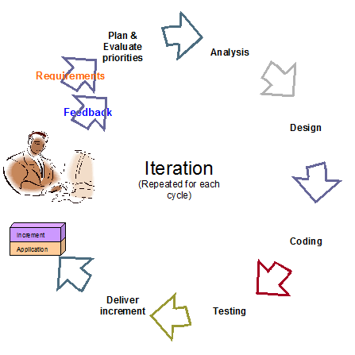

Figure 1: Agile Development Model

For more information: <http://www.indicthreads.com/1439/quick-introduction-to-agile-software-development/>

(Owner: IndicThreads.com. Online Software Developer Magazine and Conferences)

### Roles and responsibilities

|  |  |  |  |
| --- | --- | --- | --- |
| **No** | **Full name** | **Role in Group** | **Responsibilities** |
| **1** | Kiều Trọng Khánh | Project manager | * Specify user requirement * Control the development process * Give out technique and business analysis support |
| **2** | Phạm Huy Hoàng | Team Leader, BA, DEV, Tester | * Managing process * Designing database * Clarifying requirements * Prepare documents * GUI Design * Create test plan * Coding * Testing |
| **3** | Nguyễn Thanh Bình | Team Member, BA, DEV, Tester | * Designing database * Clarifying requirements * Prepare documents * GUI Design * Create test plan * Coding * Testing |
| **4** | Nguyễn Quốc Huy | Team Member, BA, DEV, Tester | * Designing database * Clarifying requirements * Prepare documents * GUI Design * Create test plan * Coding * Testing |
| **5** | Đỗ Minh Đạt | Team Member, BA, DEV, Tester | * Designing database * Clarifying requirements * Prepare documents * GUI Design * Create test plan * Coding * Testing |

Table 4: Roles and Responsibility Details

### Tools and Techniques

- Front-end technologies: HTML5, CSS3, JavaScript, jQuery, AJAX.

- Back-end: Website: ASP.NET MVC3 + Entity Framework.

Web Service: WCF. Mobile App: Android - Java.

- Web Server: Microsoft IIS.

- Database Management System: MS SQL Server 2008 Express

## Project Management Plan

### Iteration

|  |  |  |  |  |  |
| --- | --- | --- | --- | --- | --- |
| **Phase**  **/Iteration** | **Description** | **Deliverables** | **Resource needed** | **Dependencies and Constrains** | **Risks** |
| **Preliminary Investigation or Analysis** | - Study similar existing systems.  -Identify and clarify requirements for the system in general. | -Introduction of proposed system.  -Main functions.  -Project Iteration Plan. | 30 man-days | N/A | Project may  not be feasible  for developing  because lack of technologies  and/or data |
| **Face Detect & Recognize** | -Studying face detect, face recognize algorithm & library.  -Find a solution, optimize for higher performance and accuracy. | -Face Detect and Recognize System (On Web Site and Web Service) | 25 man-days | N/A | Lack of experience.  The implemented algorithm is not the best.  Lack of test data |
| **Student management** | -Manage subject, student images/information. | -Student management function | 20 man-days | Depend on “**Face Detect & Recognize”** |  |
| **Roll call management** | -Create the roll call list, based on the information of student, instructor, class and course . | -Roll call management function | 30 man-days | N/A | Lack of experience.  Not have a clear understanding about business process. |
| **Web Service Implement** | -Create and deploy the web service on server. Provide RestFul service. | -Running WCF Web Service | 25 man-days | Depend on “**Roll call management”** | Lack of experience on making and deploying web service. |
| **Attendance checking** | -Instructor use mobile app to take picture, use picture for attendance checking. | -Android App with attendance checking function | 20 man-days | Depend on “**Web Service Implement”** | Lack of experience on Android development, transfer file between Android and WCF.  No Android device available for testing. |
| **Attendance report** | -Students can view their own attendance rate.  -Instructor and admin can view reports. | -Attendance report function. | 15 man-days | N/A | Lack of experience of making report. |

Table 5: Iteration

### Iteration Detail

#### Phase 1: Preliminary Investigation or Analysis

|  |  |  |
| --- | --- | --- |
| **Task** | **Description** | **Author** |
| **1. Identifying and studying existing systems** | Find which systems currently provide similar service, their strengths and weakness. | HuyNQ, HoangPH, BinhNT |
| **2. Identifying and clarifying main functions.** | Define which main functions system should provide. | HuyNQ, HoangPH, BinhNT |
| **3. Introduction.** | Complete Introduction Report. | HoangPH |
| **4. Project Management**  **Plan.** | Prepare Project  Management Plan. | HoangPH |
| **5. Website Prototype.** | Build a prototype of proposed system (Website). | HuyNQ, HoangPH |
| **6. Mobile Prototype.** | Build a prototype of proposed system (Mobile App). | BinhNT, HoangPH |
| **7. Design ER diagram.** | Design ER diagram. | HoangPH, HuyNQ, BinhNT |

Table 6: Phase 1: Preliminary Investigation or Analysis

#### Phase 2: Face Detect & Recognize

|  |  |  |
| --- | --- | --- |
| **Task** | **Description** | **Author** |
| **1. Identifying Requirement and Planning** | Which feature this function  should have and how to  implement. | HoangPH |
| **2. Studying Face Detection & Recognition Algorithm** | Studying algorithm, implement by using library EmguCV. | HoangPH |
| **3. Extract Face from Image** | Find the faces in images, extract them for later use | HoangPH |
| **4. Recognize Face** | From the input face, find out who the face belong to | HoangPH |
| **5. Optimize** | Optimize the implement for more performance and accuracy | HoangPH |
| **6. Implement GUI** | Create the interface for extracting and storing face | HoangPH |
| **7. Testing** | Test system behavior and  performance  Test user behavior and  performance | HoangPH, HuyNQ, BinhNT, DatDM |
| **8. Document** | Adding SRS, SDD,  Installation Guide, Manual  Guide | HoangPH, HuyNQ, BinhNT, DatDM |

Table 7: Phase 2: Face Detect & Recognize

#### Phase 3: Student Management

|  |  |  |
| --- | --- | --- |
| **Task** | **Description** | **Author** |
| **1. Identifying Requirement and Planning** | Which feature this function  should have and how to  implement. | HoangPH, HuyNQ, BinhNT, DatDM |
| **2. Design ER Diagram** | Design ER Diagram | HoangPH, HuyNQ, BinhNT, DatDM |
| **3. Manage Student** | Allow admin to add/edit/active/inactive student | HuyNQ |
| **4. Manage Student Face** | Each student has a training set, which contains 8-20 faces. Allow admin to add, edit images in this training set | HuyNQ, HoangPH |
| **5. Implement GUI** | Create the interface for managing student info | HuyNQ, HoangNQ |
| **6. Testing** | Test system behavior and  performance  Test user behavior and  performance | HoangPH, HuyNQ, BinhNT, DatDM |
| **7. Document** | Adding SRS, SDD,  Installation Guide, Manual  Guide | HoangPH, HuyNQ, BinhNT, DatDM |

Table 8: Phase 3: Student Management

#### Phase 4: Roll Call Management

|  |  |  |
| --- | --- | --- |
| **Task** | **Description** | **Author** |
| **1. Identifying Requirement and Planning** | Which feature this function  should have and how to  implement. | HoangPH, HuyNQ, BinhNT, DatDM |
| **2. Manage Instructor** | Allow admin to add/edit/active/inactive instructor | DatDM |
| **3. Manage Course** | Allow admin to add/edit/active/inactive course | DatDM |
| **4. Manage Class** | Allow admin to add/edit/active/inactive course.  Assign student to class | HuyNQ |
| **5. Manage Roll Call** | Allow admin to create/edit/delete roll call.  Each roll call contain info: The instructor, the student list, the course, time, begin – end date | HuyNQ, HoangPH |
| **6. User Profile** | Instructor or student accounts will be created by system.  Instructor or student can log in to change their profile, password | HuyNQ |
| **7. Implement GUI** | Create the interface for managing roll call | HuyNQ, BinhNT, HoangPH |
| **8. Testing** | Test system behavior and  performance  Test user behavior and  performance | HoangPH, HuyNQ, BinhNT, DatDM |
| **9. Document** | Adding SRS, SDD,  Installation Guide, Manual  Guide | HoangPH, HuyNQ, BinhNT, DatDM |

Table 9: Phase 4: Roll Call Management

#### Phase 5: Web Service Implement

|  |  |  |
| --- | --- | --- |
| **Task** | **Description** | **Author** |
| **1. Identifying Requirement and Planning** | Which feature this function  should have and how to  implement. | HoangPH, HuyNQ, BinhNT, DatDM |
| **2. Studying WCF** | Studying the create and using of WCF | HuyNQ |
| **3. Instructor Login** | Check the input id and password from mobile to login instructor | HuyNQ |
| **4. Get Instructor Info, Roll Call List** | Based on the instructor’s id, show to current roll call list | HuyNQ |
| **5. Face Recognize From Android Camera** | Studying about transferring image files between Android and WCF  Transfer the result back to Mobile for showing | HuyNQ, BinhNT |
| **6. Testing** | Test system behavior and  performance  Test user behavior and  performance | HoangPH, HuyNQ, BinhNT, DatDM |
| **7. Document** | Adding SRS, SDD,  Installation Guide, Manual  Guide | HoangPH, HuyNQ, BinhNT, DatDM |

Table 10: Phase 5: Web Service Implement

#### Phase 6: Attendance Checking

|  |  |  |
| --- | --- | --- |
| **Task** | **Description** | **Author** |
| **1. Identifying Requirement and Planning** | Which feature this function  should have and how to  implement. | HoangPH, HuyNQ, BinhNT, DatDM |
| **2. Getting Image From Mobile, sending to Web Service** | Allow instructor to take picture of class, use picture for checking attendance | BinhNT |
| **3. Confirm result, re-check attendance manually** | Allow instructor to confirm and re-check attendance | BinhNT |
| **4. Stranger Alert** | Alert when detect stranger | BinhNT |
| **5. Implement Mobile App** | Create the Android App for instructor to User | BinhNT, HuyNQ, HoangNQ |
| **6. Testing** | Test system behavior and  performance  Test user behavior and  performance | HoangPH, HuyNQ, BinhNT, DatDM |
| **7. Document** | Adding SRS, SDD,  Installation Guide, Manual  Guide | HoangPH, HuyNQ, BinhNT, DatDM |

Table 11: Phase 6: Attendance Checking

#### Phase 7: Attendance Report

|  |  |  |
| --- | --- | --- |
| **Task** | **Description** | **Author** |
| **1. Identifying Requirement and Planning.** | Which feature this function  should have and how to  implement. | HoangPH, HuyNQ, BinhNT, DatDM |
| **2. Report about absent rate of a course** | System will make report about the absent rate of a course by month/year | HoangPH |
| **3. Report about absent rate of a student** | Allow instructor to confirm and re-check attendance | HoangPH |
| **4. Export Report** | Admin can export report | HuyNQ |
| **6. Testing** | Test system behavior and  performance  Test user behavior and  performance | HoangPH, HuyNQ, BinhNT, DatDM |
| **7. Document** | Adding SRS, SDD,  Installation Guide, Manual  Guide | HoangPH, HuyNQ, BinhNT, DatDM |

Table 12: Phase 7: Attendance Report

### All Meeting Minutes

Refer to Meeting Minutes folder.

## Coding Convention

Java: Using to develop Android App.

Summary:

* Naming Convention.
* Indentation.
* Declaration.
* Code Examples

Follow “Code Conventions for the Java TM Programming Language, by Sun Microsystems, rev April 20, 1999”.

C#: Using to develop website and web service.

Summary:

* Naming Convention.
* Layout Convention.
* Commenting Convention.
* Language Guidelines

Using C# Code Convention From:

<http://msdn.microsoft.com/en-us/library/vstudio/ff926074.aspx>

# Software Requirement Specification

## User Requirement Specification

### Guest Requirement

### Instructor Requirement

### Staff Requirement

### Student Requirement

### Admin Requirement

### System Requirement

## System Requirement Specification

### External Interface Requirement

#### User Interface

#### Hardware Interface

#### Software Interface

#### Communication Protocol

### System Overview Use Case

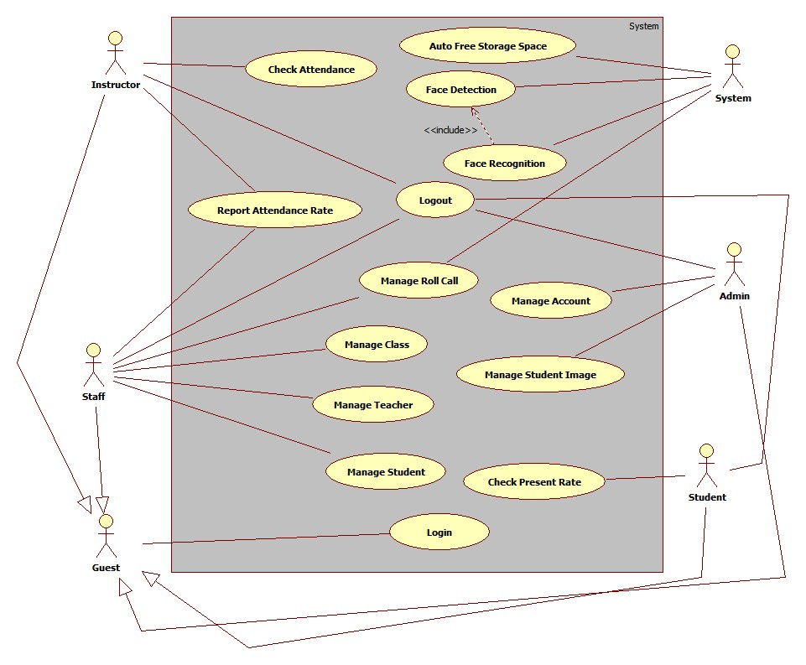

Figure System Overview Use Case

### List of Use Case

#### <Guest>Overview Use Case

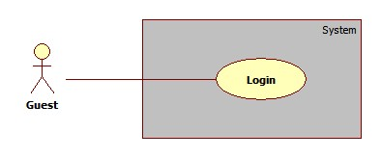

Figure : <Guest> Overview Use Case

##### <Guest> Login

Use Case Diagram



Figure : <Guest> Login

Use Case Specification

|  |  |  |  |
| --- | --- | --- | --- |
| **USE CASE – GU001** | | | |
| **Use Case No.** | GU001 | **Use Case Version** | 1.0 |
| **Use Case Name** | Login | | |
| **Author** | Pham Huy Hoang | | |
| **Date** | 19/09/2013 | **Priority** | Normal |
| **Actor:** Guest.  **Summary:**  Customer uses this case to view shopping cart.  **Goal:**  Allow customer views list of product on their shopping cart.  **Triggers:**  - Customer can view all products that they added to shopping cart. They also can  update quantity of product, delete product or choose product’s size.  - Customer clicks on icon shopping cart on header of page to view shopping cart.  **Preconditions:** N/A.  **Post Conditions:**  - Success: System will transfer to view cart page and show all products in shopping  cart.  **Fail:** System will transfer to error page or still in current page.  **Main Success Scenario:**   |  |  |  | | --- | --- | --- | | Step | Actor Action | System Response | |  |  |  | |  |  |  |   **Alternative Scenario:** N/A  **Exceptions:** N/A  **Relationships:** Manage Order  **Business Rules:** | | | |

Table : <Guest> Login

#### < Instructor>Overview Use Case

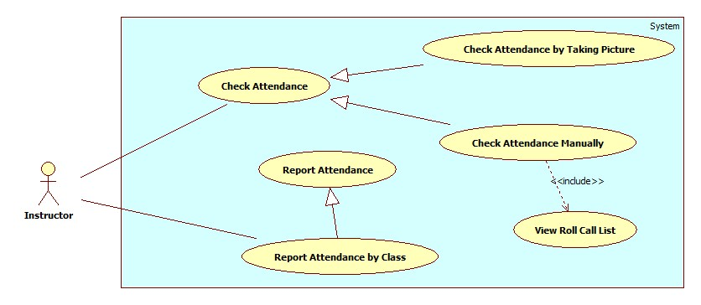

##### <Instructor> Check Attendance by Taking Picture

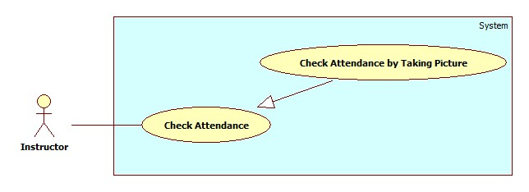

|  |  |  |  |
| --- | --- | --- | --- |
| **USE CASE – IU001** | | | |
| **Use Case No.** | IU001 | **Use Case Version** | 2.0 |
| **Use Case Name** | Check Attendance by Taking Picture | | |
| **Author** | Nguyen Thanh Binh | | |
| **Date** | 23/09/2013 | **Priority** | Normal |
| **Actor:** Instructor.  **Summary:**  Instructor uses this case to check attendance.  **Goal:**  Allow instructor capture image, send image to web service and check attendance.  **Triggers:**  Instructor can use mobile to take picture. This picture will be used for attendance checking ... To check attendance using picture, instructor must do:  - Instructor login application and click button “Attendance” in Course page. System transfer to “Capture” Page.  - On “capture” page, Instructor capture image, then send image to web service for detected face of member.  - Instructor receive result from Web service. Instructor view result and check attendance for members.  **Preconditions:**   * User must logged in the system with the role is Instructor   **Post Conditions:**  - **Success**: Instructor can check attendance for member. System will send image and receive result from web service.  **- Fail:** System will transfer to error page or still in current page.  **Main Success Scenario:**   |  |  |  | | --- | --- | --- | | Step | Actor Action | System Response | | 1 | Instructor type username, password to login application. | System will show the Course page with information includes:  - Instructor name: Text  - Course name: Text  - Class name: Text  - Attendance: Number Information about Course (Assignment, quiz …): Text  **Main menu:**  Report: Button  Attendance: Button  Course: drop down list  Class: drop down list | | 2 | After chose course, class on class time. Instructor click button Attendance to capture picture. | System transfer to Capture page with:   * Camera screen view: Frame layout * Capture: Button | | 3 | Instructor look at screen and click “Capture” button to capture image and send image to web service. | System will save image on real time when instructor click button “Capture” and send to web service. Then, system create an alert show (popup) about “sending success”.  Instructor click “OK” button to return Course page. | | 4 | Instructor receive result from web service by notification and check attendance. | System will shake to notify for Instructor about result from web service. Instructor check report then click “Report” button transfer to Roll Call page:   * Roll call: Text * Instructor Name: Text * Class Name: drop down list * Course Name: drop down list * Date & Time: Calendar * Student List(No., Name, Code, Status, Checkbox ) * Check/Uncheck: Button * Attendance: Button |   **Alternative Scenario:** N/A  **Exceptions:**   |  |  |  | | --- | --- | --- | | Step | Actor Action | System Response | | 1 | No camera | System will show alert (popup) “Camera not found”. | | 2 | No internet. | System will show alert (popup) “Sending fail”. Instructor click “OK” button to retake an image. |   **Relationships:** Check attendance  **Business Rules:**   * Instructor can check present member easily. | | | |

##### <Instructor> Check Attendance Manually

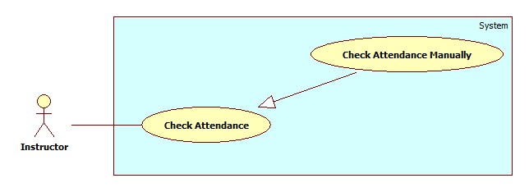

|  |  |  |  |
| --- | --- | --- | --- |
| **USE CASE – IU002** | | | |
| **Use Case No.** | IU002 | **Use Case Version** | 2.0 |
| **Use Case Name** | Check Attendance by Taking Picture | | |
| **Author** | Nguyen Thanh Binh | | |
| **Date** | 23/09/2013 | **Priority** | Normal |
| **Actor:** Instructor.  **Summary:**  Instructor uses this case to check attendance.  **Goal:**  Allow instructor check attendance again for member have special reason.  **Triggers:**  Instructor can use mobile to take picture. This picture will be used for attendance checking ... To check attendance using picture, instructor must do:  - Instructor login application and click button “Report” in Course page. System transfer to “Roll Call” Page.  - Instructor review all members and check attendance for member have special reason on this day or previous day.  **Preconditions:**   * User must logged in the system with the role is Instructor   **Post Conditions:**  - **Success**: Instructor can check attendance for member on this day or previous day.  **- Fail:** System will transfer to error page or still in current page.  **Main Success Scenario:**   |  |  |  | | --- | --- | --- | | Step | Actor Action | System Response | | 1 | Instructor type username, password to login application. | System will show the Course page with information includes:  - Instructor name: Text  - Course name: Text  - Class name: Text  - Attendance: Number Information about Course (Assignment, quiz …): Text  **Main menu:**  Report: Button  Attendance: Button  Course: drop down list  Class: drop down list | | 2 | After chose course, class on class time. Instructor click button Report to check attendance. | Instructor check report then click “Report” button transfer to Roll Call page:   * Roll call: Text * Instructor Name: Text * Class Name: drop down list * Course Name: drop down list * Date & Time: Calendar * Student List(No., Name, Code, Status, Checkbox ) * Check/Uncheck: Button * Attendance: Button | | 3 | Instructor, choose current day or previous day, choose course & class, then click checkbox with Student List (or click button “Check/Uncheck” to check All). | System show Student List flow course, class and day includes: Roll call, subject, instructor, class, date, time, student list (No., name, Code, Status, Check box). | | 4 | Click button “Attendance” (submit) send request to check attendance for present member. | System will send request check attendance for present member to server. |   **Alternative Scenario:** N/A  **Exceptions:**   |  |  |  | | --- | --- | --- | | Step | Actor Action | System Response | | 1 | No internet. | System will show alert (popup) “Sending fail”. Instructor click “OK” button to transfer Roll Call page. |   **Relationships:** Check attendance  **Business Rules:**   * Instructor can check present member easily. | | | |

##### <Instructor> View Roll Call List

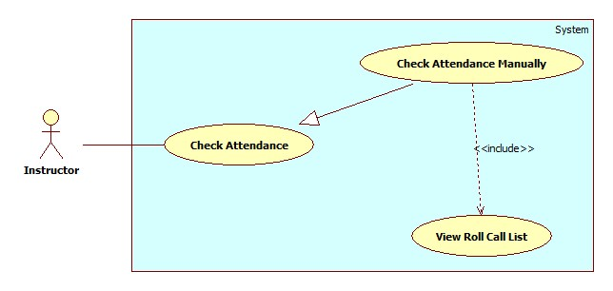

|  |  |  |  |
| --- | --- | --- | --- |
| **USE CASE – IU003** | | | |
| **Use Case No.** | IU003 | **Use Case Version** | 2.0 |
| **Use Case Name** | View Roll Call List | | |
| **Author** | Nguyen Thanh Binh | | |
| **Date** | 23/09/2013 | **Priority** | Normal |
| **Actor:** Instructor.  **Summary:**  Instructor uses this case to view all roll call list.  **Goal:**  Allow instructor view roll call list with current day or previous day to check attendance again for member have special reason.  **Triggers:**  - Instructor login application and click button “Report” in Course page. System transfer to “Roll Call” Page.  - Instructor review all members with course, class and selected day.  **Preconditions:**   * User must logged in the system with the role is Instructor   **Post Conditions:**  - **Success**: Instructor can view list of members on current day or previous day with selected course, class.  **- Fail:** System will transfer to error page or still in current page.  **Main Success Scenario:**   |  |  |  | | --- | --- | --- | | Step | Actor Action | System Response | | 1 | Instructor type username, password to login application. | System will show the Course page with information includes:  - Instructor name: Text  - Course name: Text  - Class name: Text  - Attendance: Number Information about Course (Assignment, quiz …): Text  **Main menu:**  Report: Button  Attendance: Button  Course: drop down list  Class: drop down list | | 2 | After chose course, class on class time. Instructor click button Report to check attendance. | Instructor check report then click “Report” button transfer to Roll Call page:   * Roll call: Text * Instructor Name: Text * Class Name: drop down list * Course Name: drop down list * Date & Time: Calendar * Student List(No., Name, Code, Status, Checkbox ) * Check/Uncheck: Button * Attendance: Button | | 3 | Instructor, choose current day or previous day, choose course & class. | System show Student List flow course, class and day includes: Roll call, subject, instructor, class, date, time, student list (No., name, Code, Status, Check box). |   **Alternative Scenario:** N/A  **Exceptions:** N/A  **Relationships**  **Business Rules:**   * Instructor can view all roll call list, help to review status of student and check attendance again for members have special reason. | | | |

##### <Instructor> Report Attendance by Class

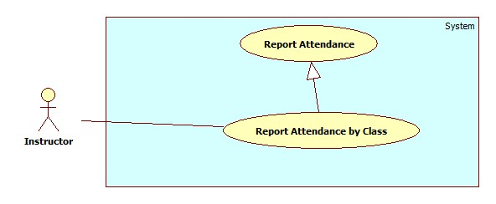

|  |  |  |  |
| --- | --- | --- | --- |
| **USE CASE – IU004** | | | |
| **Use Case No.** | IU004 | **Use Case Version** | 2.0 |
| **Use Case Name** | Report by Class. | | |
| **Author** | Nguyen Thanh Binh. | | |
| **Date** | 23/09/2013 | **Priority** | Normal |
| **Actor:** Instructor.  **Summary:**  This use case allows staff report attendance of all students by class.  **Goal:**  Instructor can report attendance of class.  **Triggers:**   * Instructor can report information of class: subject, student, attendance… * Instructor must do these step to view report result:   + On Home page, click on link ”Report” in menu bar and Report page will be showed.   + Then, in select box “Report by” choose type: Class.   + Then, in drop down list “Name” chose the class name.   + Click on button “Statistic”.   **Preconditions:**   * User must logged in the system with the role is Instructor.   **Post Conditions:**   * **Success**: A report attendance by class will be showed on screen. * **Fail:** System will not return any value. Transfer to error page or still in current page.   **Main Success Scenario:**   |  |  |  | | --- | --- | --- | | Step | Actor Action | System Response | | 1 | Click “Report” link in menu bar. | Redirect to Report Page, include 4 part:   * Drop down list “Report by” (value: Class, Student, Block, and Semester). * Drop down list “Name” (value: auto set based on drop down list Report by) * Button “Statistic” * Button “Export”. | | 2 | Choose “Class” in drop down list Report by. | System will auto set value based on type Class. | | 3 | Chose the class in drop down list “Name”. Click button “Statistic” | System will show result attendance by class on screen.  System still in current “Report” page. |   **Alternative Scenario:** N/A  **Exceptions:** N/A  **Relationships:** Manage Report Attendance.  **Business Rules:**   * System will show attendance result in chosen conditions. * Default value when manager clicks on tab “Report” is: Class. | | | |

#### < Staff >Overview Use Case

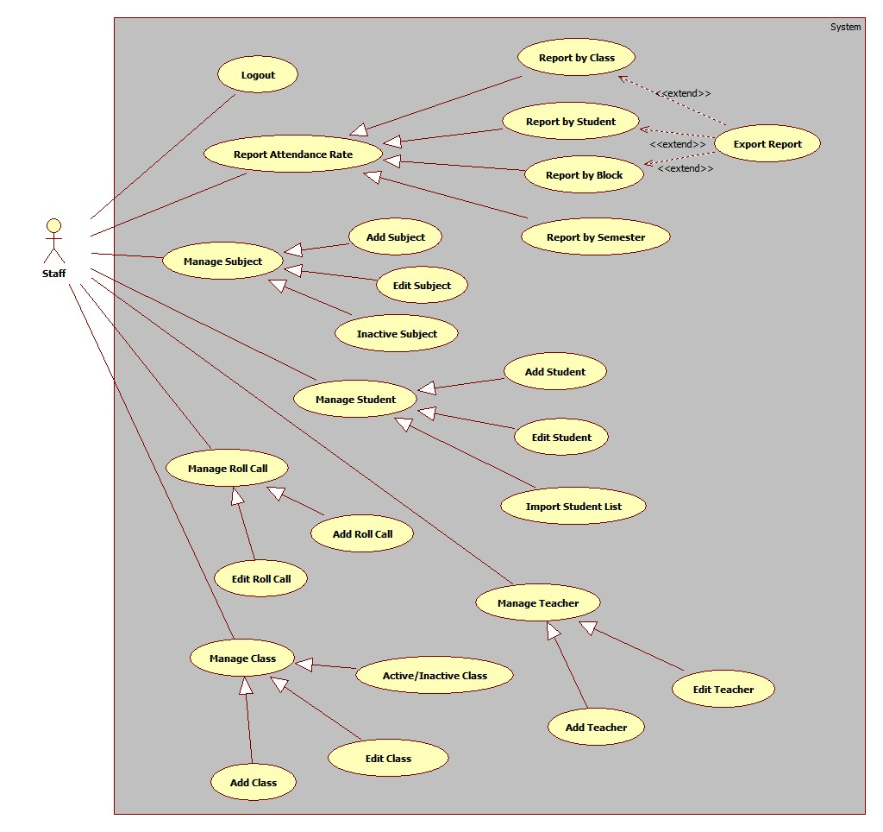

#### <Student>Overview Use Case

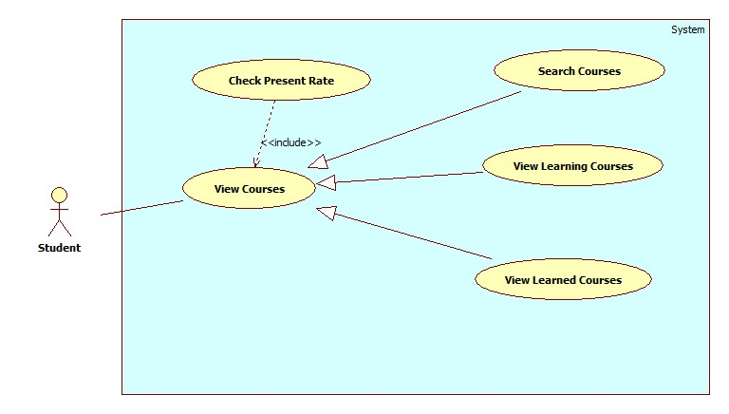

##### <Student>Check Present Rate by Searched Course

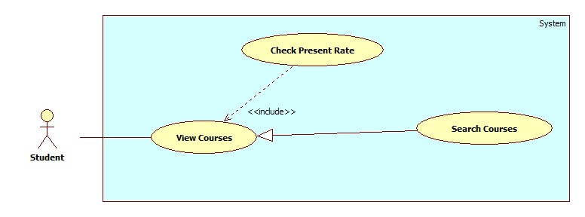

|  |  |  |  |
| --- | --- | --- | --- |
| **USE CASE – STU001** | | | |
| **Use Case No.** | STU001 | **Use Case Version** | 2.0 |
| **Use Case Name** | Check Present Rate by Searched Course | | |
| **Author** | Nguyen Thanh Binh | | |
| **Date** | 23/09/2013 | **Priority** | Normal |
| **Actor:** Student.  **Summary:**  Student uses this case to search learned/learning course.  **Goal:**  Allow student views learned/learning course info. The search condition is course name.  **Triggers:**  - Student can search course name on list course page. The searching results follow course name.  - On list courses page, student choose search condition and clicks search button. System will show list search in list course table at current page.  - On list search page, student choose the course. System will show information detail about that course.  **Preconditions:**   * User must logged in the system with the role is Student.   **Post Conditions:**  - **Success**: The search course will be found. System will show list search in lists course page.  **- Fail:** System will transfer to error page or still in current page.  **Main Success Scenario:**   |  |  |  | | --- | --- | --- | | Step | Actor Action | System Response | | 1 | At lists course page, student choose search condition | System will show the search condition include:   * Course Name: text box | | 2 | After chose search condition, student clicks on search button (submit button) finish. | System will show list search of courses that student searched by condition in List Course table.  List Courses table includes 5 column: No (number), Course Name, Semester, Time, Present Rate. | | 3 | Ai list course table, student choose the course they want to view and click on that course name. | System will show information about that course in current page.  Information course includes: Roll call, Course Name, Semester, Time, Student Name & Code, Present, Present Rate and Detail (about exactly day present or absent) |   **Alternative Scenario:** N/A  **Exceptions:**   |  |  |  | | --- | --- | --- | | Step | Actor Action | System Response | | 1 | Search not found | System will show “No course was found!” |   **Relationships:** Check Present Rate  **Business Rules:**   * The courses will be search by course name. * Student can use search course to view their course easily. | | | |

##### <Student>Check Present Rate by Learned Course

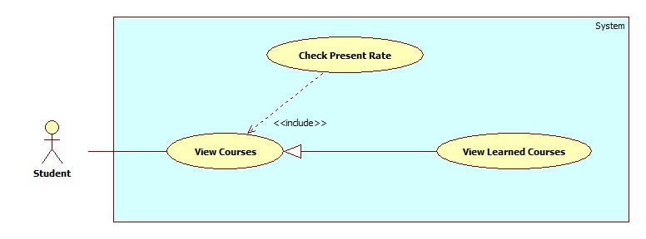

|  |  |  |  |
| --- | --- | --- | --- |
| **USE CASE – STU002** | | | |
| **Use Case No.** | STU002 | **Use Case Version** | 2.0 |
| **Use Case Name** | Check Present Rate by Learned Course | | |
| **Author** | Nguyen Thanh Binh | | |
| **Date** | 23/09/2013 | **Priority** | Normal |
| **Actor:** Student.  **Summary:**  Student uses this case to search learned course.  **Goal:**  Allow student views learned course info. The search condition is semester.  **Triggers:**  - On list learned courses page, student choose search condition. System will show list search in list course table at current page.  - On list search page, student choose the course. System will show information detail about that course.  **Preconditions:**   * User must logged in the system with the role is Student.   **Post Conditions:**  - **Success**: The search course will be found. System will show list search in lists course page.  **- Fail:** System will transfer to error page or still in current page.  **Main Success Scenario:**   |  |  |  | | --- | --- | --- | | Step | Actor Action | System Response | | 1 | At lists course page, student choose search condition | System will show the search condition include:   * Semester: drop down list | | 2 | After chose search condition, student view list learned course will be show on current page. | System will show list search of courses that student searched by condition in List Course table.  List Courses table includes 5 column: No (number), Course Name, Semester, Time, Present Rate. | | 3 | Ai list course table, student choose the course they want to view and click on that course name. | System will show information about that course in current page.  Information course includes: Roll call, Course Name, Semester, Time, Student Name & Code, Present, Present Rate and Detail (about exactly day present or absent) |   **Alternative Scenario:** N/A  **Exceptions:** N/A  **Relationships:** Check Present Rate  **Business Rules:**   * The learned courses will be search by semester. * Student can use search course to view their course easily. | | | |

##### <Student>Check Present Rate by Learning Course

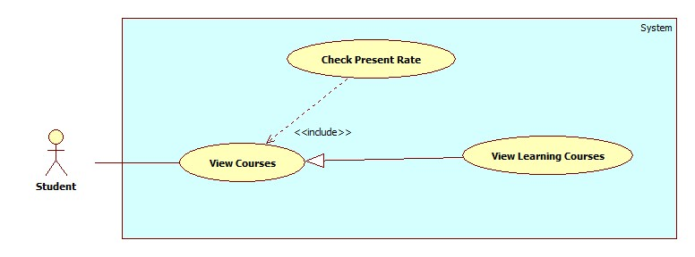

|  |  |  |  |
| --- | --- | --- | --- |
| **USE CASE – STU003** | | | |
| **Use Case No.** | STU003 | **Use Case Version** | 2.0 |
| **Use Case Name** | Check Present Rate by Learning Course | | |
| **Author** | Nguyen Thanh Binh | | |
| **Date** | 23/09/2013 | **Priority** | Normal |
| **Actor:** Student.  **Summary:**  Student uses this case to search learning course.  **Goal:**  Allow student views learning course info.  **Triggers:**  - On list learning courses page student choose the course. System will show information detail about that course.  **Preconditions:**   * User must logged in the system with the role is Student.   **Post Conditions:**  - **Success**: The search course will be found. System will show list search in lists course page.  **- Fail:** System will transfer to error page or still in current page.  **Main Success Scenario:**   |  |  |  | | --- | --- | --- | | Step | Actor Action | System Response | | 1 | Student choose view Learning Course page. | System will show list learning courses. List Courses table includes 5 column: No (number), Course Name, Semester, Time, Present Rate. | | 2 | Ai list course table, student choose the course they want to view and click on that course name. | System will show information about that course in current page.  Information course includes: Roll call, Course Name, Semester, Time, Student Name & Code, Present, Present Rate and Detail (about exactly day present or absent) |   **Alternative Scenario:** N/A  **Exceptions:** N/A  **Relationships:** Check Present Rate  **Business Rules:**   * Student can use search course to view their course easily. | | | |

#### <User> Overview Use case

##### <User> Change Password

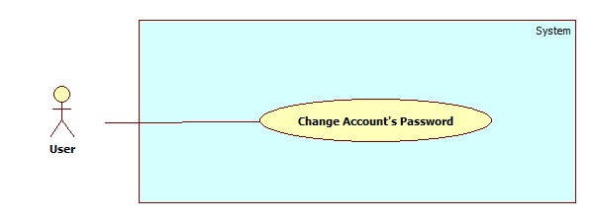

|  |  |  |  |
| --- | --- | --- | --- |
| **USE CASE – UU001** | | | |
| **Use Case No.** | UU001 | **Use Case Version** | 2.0 |
| **Use Case Name** | Change Password | | |
| **Author** | Nguyen Thanh Binh | | |
| **Date** | 23/09/2013 | **Priority** | Normal |
| **Actor:** User (Instructor, Staff, Student, Admin).  **Summary:**  User users this case to change their password.  **Goal:**  Allow users can change their password.  **Triggers:**  User use this use case to help improve their account security.  - User login their account, click “Change Password” link. Go to “Change Password” page.  **Preconditions:**   * User must logged in the system with the role is User (Staff, Instructor, Student, Admin).   **Post Conditions:**  - **Success**: The password be changed.  **- Fail:** System will transfer to error page or still in current page.  **Main Success Scenario:**   |  |  |  | | --- | --- | --- | | Step | Actor Action | System Response | | 1 | User selects the “Change Password” command in the top-right column of Home page. | System will show “Change Password” page includes:   * Username – Text box * Current Password – Text box * New Password – Text box * Confirm New Password – Text box * Submit – Button * Reset - Button | | 2 | User enters the following information (Username, Current Password, New password, Confirm new password).  Click “Submit” button to send request. | * System changes the user’s password. * System automatically re-authenticates the user with the new credentials. * System will show “Your password was changed successfully!” * System presents message confirming that the password was changed successfully. |   **Alternative Scenario:** N/A  **Exceptions:**   |  |  |  | | --- | --- | --- | | Step | Actor Action | System Response | | 1 | System verifies that the Username and Current Password entries are correct and correspond to a current user. | System will show “Wrong username/ password” and reset all. | | 2 | New password same current password | System will show “New password was used! Please choose new password” and reset all. | | 3 | New password and confirm new password does not match. | System will show “Password does not match” and reset all. |   **Relationships:**  **Business Rules:N/A** | | | |

##### <User>Logout

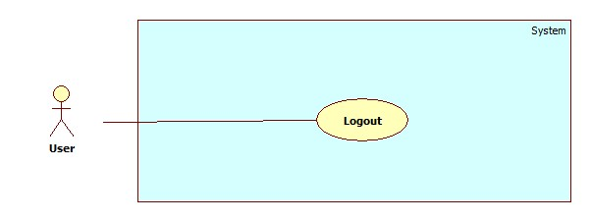

|  |  |  |  |
| --- | --- | --- | --- |
| **USE CASE – UU002** | | | |
| **Use Case No.** | UU002 | **Use Case Version** | 2.0 |
| **Use Case Name** | Change Password | | |
| **Author** | Nguyen Thanh Binh | | |
| **Date** | 23/09/2013 | **Priority** | Normal |
| **Actor:** User (Instructor, Staff, Student, Admin).  **Summary:**  User use this use case to logout system.  **Goal:**  The user selects the option to log off of the HCPT website and is then redirected back to the Login page.  **Triggers:**  The use case starts when the user selects the option to logout.   * The user selects the option to logout. * The system informs the user of logging out. * The user confirms logging out. * The system redirects user back to the Login page.   **Preconditions:**   * User must logged in the system with the role is User (Staff, Instructor, Student, Admin).   **Post Conditions:**  - **Success**: User logout system and redirect to login page.  **- Fail:** System will transfer to error page or still in current page.  **Main Success Scenario:**   |  |  |  | | --- | --- | --- | | Step | Actor Action | System Response | | 1 | The user selects log out. The system prompts for user confirmation. The user selects Yes to log out. The user logs out successfully. | The system will move the user session and the user is logged out |   **Alternative Scenario:** N/A  **Exceptions:**   |  |  |  | | --- | --- | --- | | Step | Actor Action | System Response | | 1 | The user selects log out. The system prompts for user confirmation. The user selects No. The user does not log out successfully. The user stay at current page. | System hide the popup and show current page. |   **Relationships:**  **Business Rules:N/A** | | | |

#### <Admin>Overview Use Case

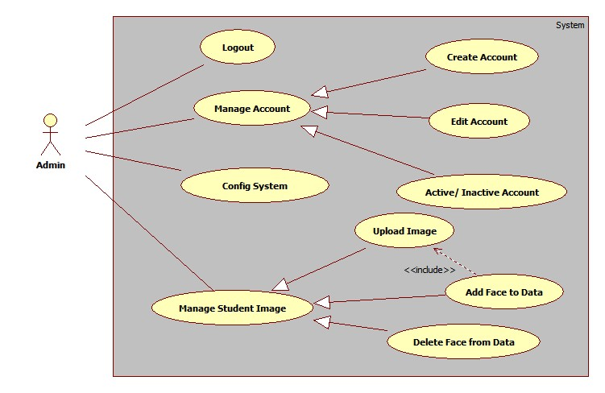

#### <System>Overview Use Case

